

**OCEANOGRAPHY DATA ACQUISITION SYSTEM FOR LAGOONS**

RATHNAYAKA MUDIYANSELAGE JANITH SHEHAN RATHNAYAKA

A dissertation submitted in partial fulfilment of the requirements for the Bachelor of Science External Degree in Electronic and Automation Technology

Of the

University of Colombo, Sri Lanka

DECEMBER 2022

**DECLARATION**

I certify that this dissertation does not incorporate without acknowledgement, any material previously submitted for a degree or Diploma in any university and to the best of my knowledge and belief it does not contain any material previously published or written or oral communicated by other person except where due reference is made in the text.



…………………………..

R.M.J.S. RATHNAYAKA

**ACKNOWLEDGEMENT**

I have taken efforts in this project. However, it would not have been possible without the kind support and help of many individuals and organizations. I would like to extend my sincere thanks to all of them.

I am highly indebted to Dr. Hiran Jayaweera, Mr. Sameera Viraj for their guidance and constant supervision as well as for providing necessary information regarding the project & also for their support in completing the project.

I would like to express my special gratitude and thanks to Dr. Priyantha Jinadasa who is senior lecturer of Ocean University of Sri Lanka for giving me such attention and time.

I would like to express my gratitude towards my parents & family member for their kind cooperation and encouragement which help me in completion of this project.

My thanks and appreciations also go to my colleague in developing the project and people who have willingly helped me out with their abilities.

**Abstract**

Lagoons consist with varies of environments and such elements of ocean environment systems. Those environment systems changes or transformations can occur because of the effect of the climate changes and human behaviors. Scientists measure those changes using parameters such as Temperature, Salinity, and Turbidity. Data acquisition system was invented for lagoons using an Arduino microcontroller and ESP32. Temperature sensor and Turbidity sensor are used for the sensor network. This device is consisting with two parts of Transmitter (Sensor network) and Receiver. LoRa data transmission method was used for the data transmission between the transmitter and receiver.

Contents

1 Introduction 7

2 Background 8

2.1 Objective of Project 8

3 Methodology 9

3.1 Design architecture 9

3.2 Sensor Network 10

3.2.1 Arduino Uno 10

3.2.2 DS18B20 11

3.2.3 Turbidity 12

3.3 Battery Circuit 13

3.4 LoRa 13

3.5 Receiver Circuit 14

3.5.1 Web Application 15

3.5.2 Encloser Designing and Manufacturing 16

4 Result and Discussion 16

4.1 Final Product 16

4.2 Data visualization of web app 17

5 Conclusion 17

**List of Figures**

Figure 1:Design Architecture 9

Figure 2: Sensor Network 10

Figure 3:Arduino Uno 10

Figure 4: Temperature sensor 11

Figure 5:Turbidity Sensor 12

Figure 6:Battery Circuit 13

Figure 7: LoRa Module 13

Figure 8: Receiver Circuit 14

Figure 9:Firmware Configuration 16

Figure 10: 3D model of Encloser 16

# Introduction

Lagoons consist with varies of environments and such elements of ocean environment systems. Those environment systems changes or transformations can occur because of the effect of the climate change and human behaviors[1].

Thereby, some social activities occur to the change elements and environment of lagoons. Scientists measure those changes using parameters such as Temperature, Salinity, and Turbidity[2]. Estuarine areas are forming because of the river’s discharge on lagoons. There are so many devices used for get oceanographical data such as Salinity Reflectometer, Portable EC/pH/TDC meters[3]. Those economical changes affect to marine eco system to directly. This marine ecosystem consists with, humans, Fish, Birds and marine plants.

There is kind of data acquisition method in the world such as satellite imaginary, climate buoys, remotely operated vehicles, and manually[4]. When we take these measurements manually, accuracy depends with who take measurements. Because some data points can be missed. But if we use automatic data collecting devices, we can take all the data with specific time intervals.

I invent the new design of marine data acquisition system co collect data from lagoons remotely. New design has several features such as can get data from maximum distance 200m, can get two data in onetime, easy to analyze an easy to setup device. This device consists with microcontrollers, sensor modules and DC power supply.

# Background

Sri Lanka is Island which has 980 km2 area of sea[5]. Sri Lankan marine industry need technology invent to conduct their research. Manual data collection is less accuracy and efficiency there for automatic data acquisition systems help to increase the accuracy and efficiency of the data sampling and analyzing[6].

## Objective of Project

The objective of this project is to develop a method to collect data samples from lagoons by remotely with the following targets,

* Collect data from coast
* Collect multiple data in real time
* To get real time graphical view of data
* Increase the accuracy of the data

# Methodology

## Design architecture

This device is consisting with two parts of Transmitter (Sensor network) and Receiver. LoRa data transmission method was used for the data transmission between the transmitter and receiver. Transmitter and receiver are the separate devices. In transmitter side sensors collect data and it transfer data to receiver through LoRa modules.

LoRa module in receiver side, transfer data to ESP32 module and it transfer data to web app trough Wi-Fi transmission.

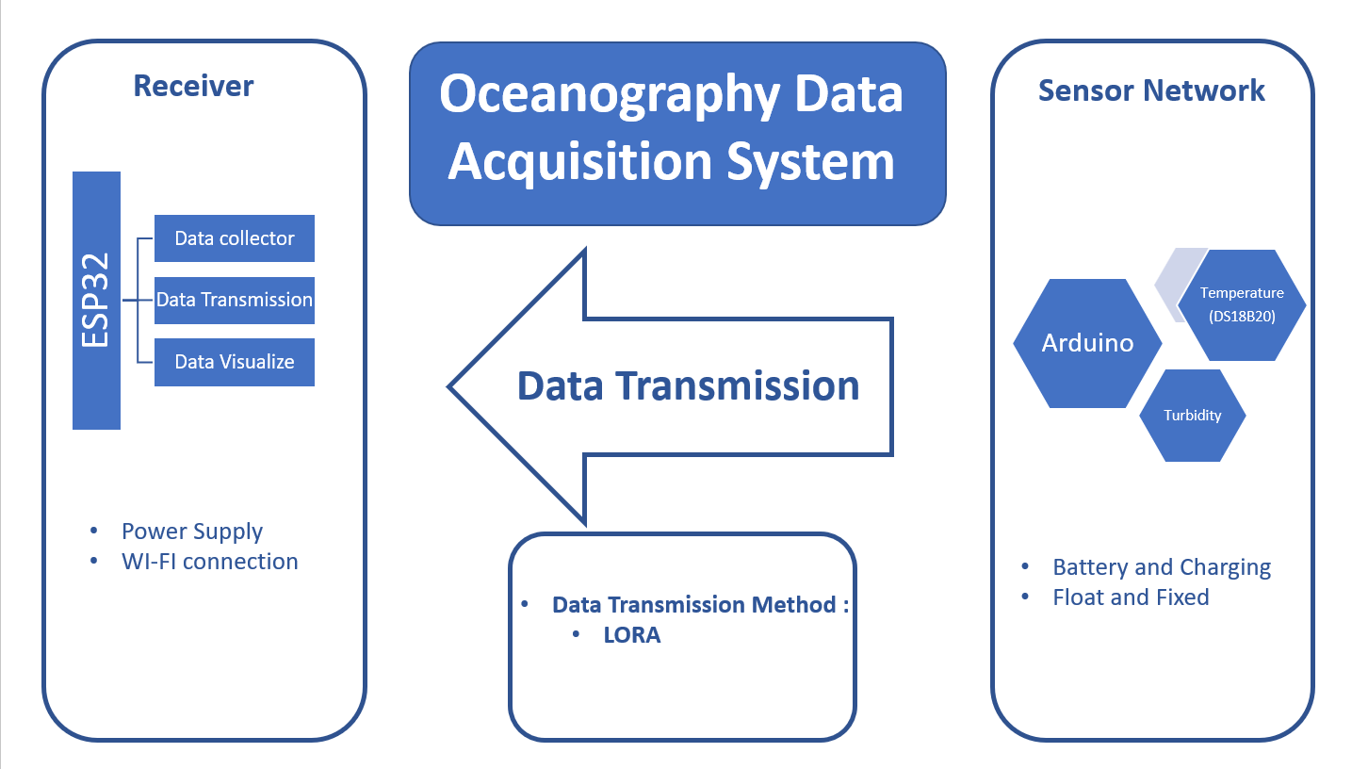

Figure :Design Architecture

## Sensor Network

Sensor Network has two parts of Power circuit and Sensor circuit. In sensor circuit has DS18B20 temperature sensor and turbidity sensor. Sensor network controlled with the Arduino UNO.

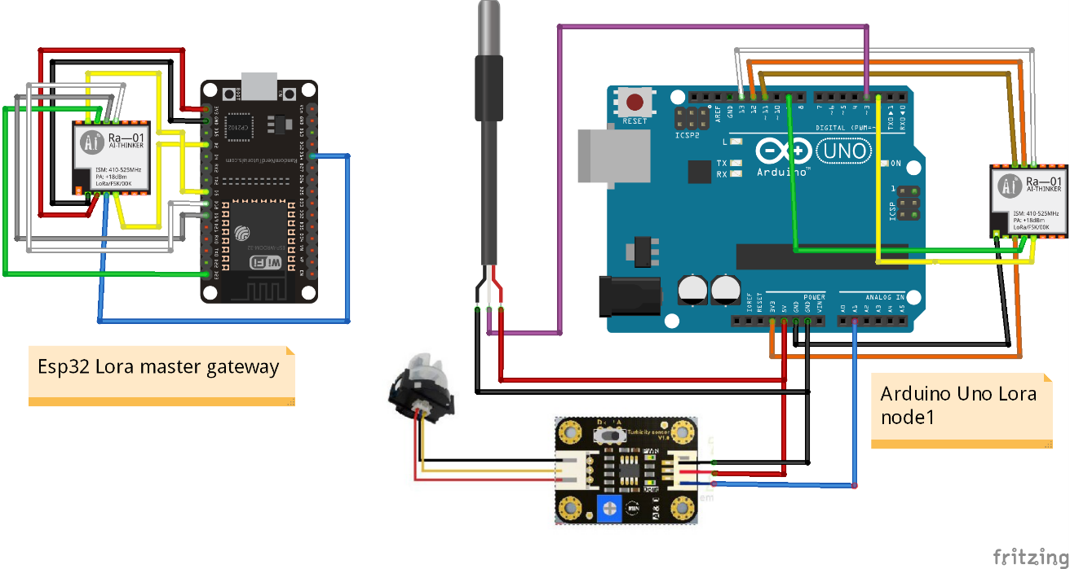

Figure : Sensor Network

### Arduino Uno

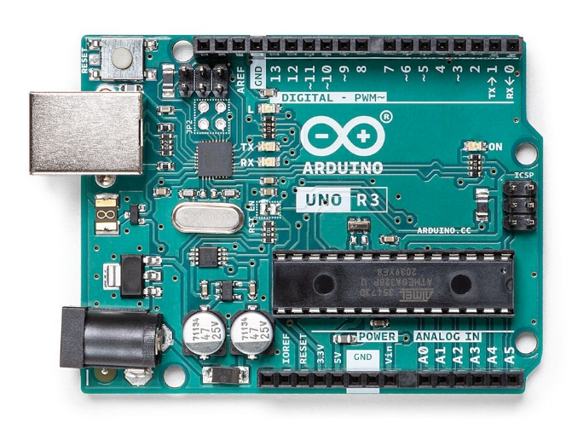

Figure :Arduino Uno

A microcontroller board called Arduino Uno is based on the ATmega328P. (datasheet). It has a 16 MHz ceramic resonator (CSTCE16M0V53-R0), 6 analog inputs, 14 digital input/output pins (of which 6 can be used as PWM outputs), a USB port, a power jack, an ICSP header, and a reset button. It comes with everything needed to support the microcontroller; to get started, just plug in a USB cable, an AC-to-DC adapter, or a battery[7].

### DS18B20

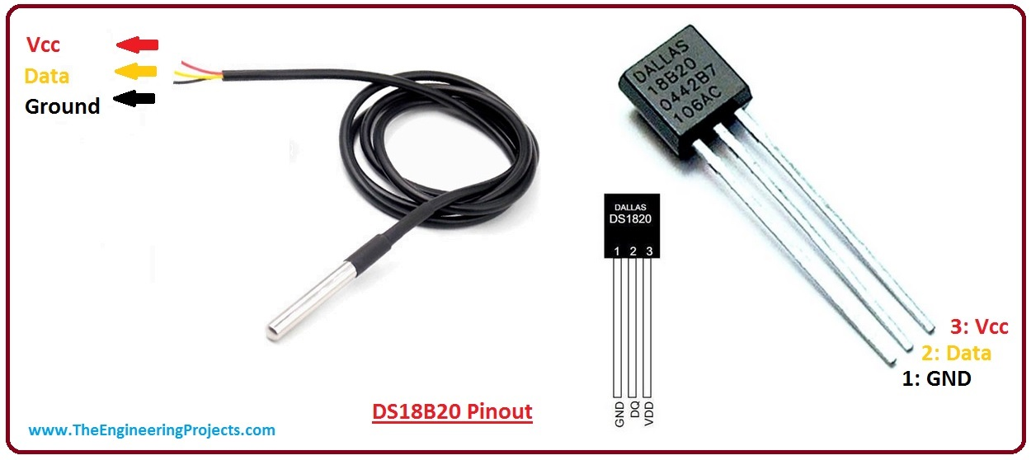

Figure : Temperature sensor

Maxim Integrated makes the DS18B20, a 1-wire programmable temperature sensor. In harsh settings like chemical solutions, mines, or soil, it is frequently employed to gauge temperature. The sensor's enclosure is sturdy and has the option to be waterproof, which makes installing it simple. With a respectable accuracy of 5°C, it can measure a wide range of temperatures, from -55° to +125°[8].

Since each sensor has a distinct address and only uses one MCU port to transfer data, it is a great option for taking several temperature measurements without using up many of your microcontroller's digital pins.

### Turbidity

The gravity DfRobot's Arduino Turbidity Sensor measures turbidity levels to determine the condition of the water. The amount of total suspended solids (TSS) in the water affects the light's transmittance and scattering rate, which can be used to identify suspended particles in the water. The level of liquid turbidity rises as the TTS rises[9].

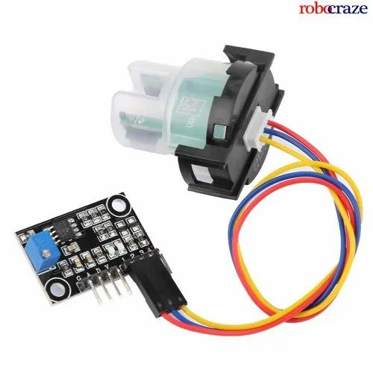

Figure :Turbidity Sensor

## Battery Circuit

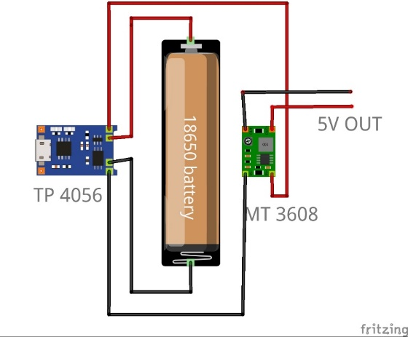

Figure :Battery Circuit

Sensor network with Arduino Uno powered by 18650 battery using MT 3608 DC to DC converter. MT3608 convert 3.7V to 5V. And TP 4056 charging module used to recharge the battery.

## LoRa

LoRa Technology has been used for the data transmission between transmitter and receiver. A firm called Semtech created LoRa technology, a new wireless protocol created exclusively for long-range, low-power communications. Long Range Radio, or LoRa, is primarily aimed at M2M and IoT networks. With the help of this technology, numerous apps running on the same network will be able to connect through public or multi-tenant networks[10].

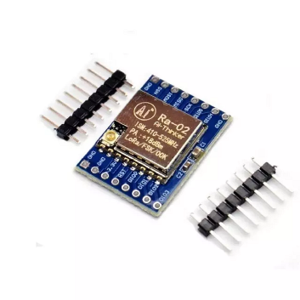

Figure : LoRa Module

## Receiver Circuit

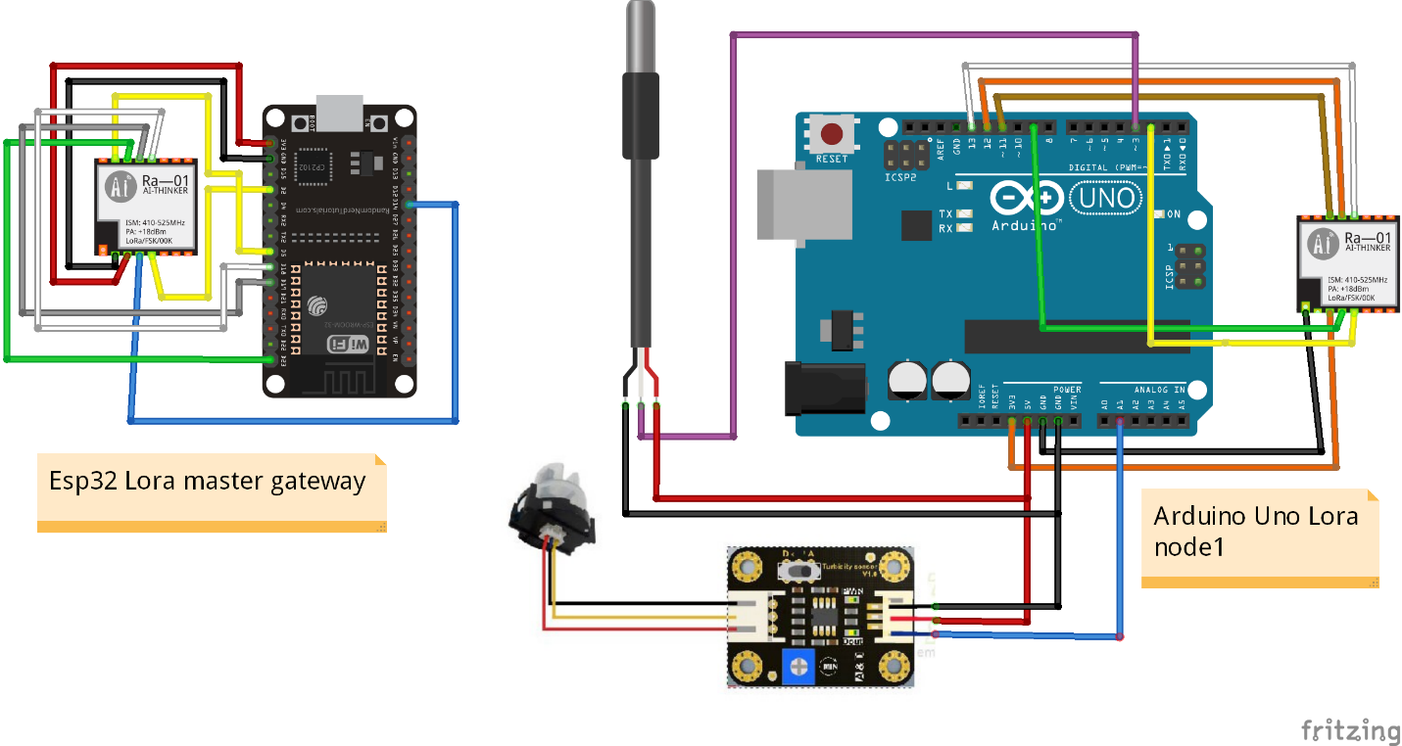

Figure : Receiver Circuit

Receiver Circuit consist with ESP32 and LoRa module. Transmitter directly transmit data to the LoRa module and LoRa module share data to the ESP32. ESP32 connect the web app with Wi-Fi. ESP32 used to the receiver circuit because of it has inbuild Wi-Fi module.

### Web Application

Web application created with Blynk web software. Blynk is choice to the data visualization because of it is easy to build and easy to access with any device. Blynk is an Internet-of-Things platform for iOS or Android smartphones that allows users to remotely operate devices like Arduino, Raspberry Pi, and NodeMCU. Using this application, you can compile and provide the right address on the various widgets to construct a graphical interface or human machine interface (HMI).

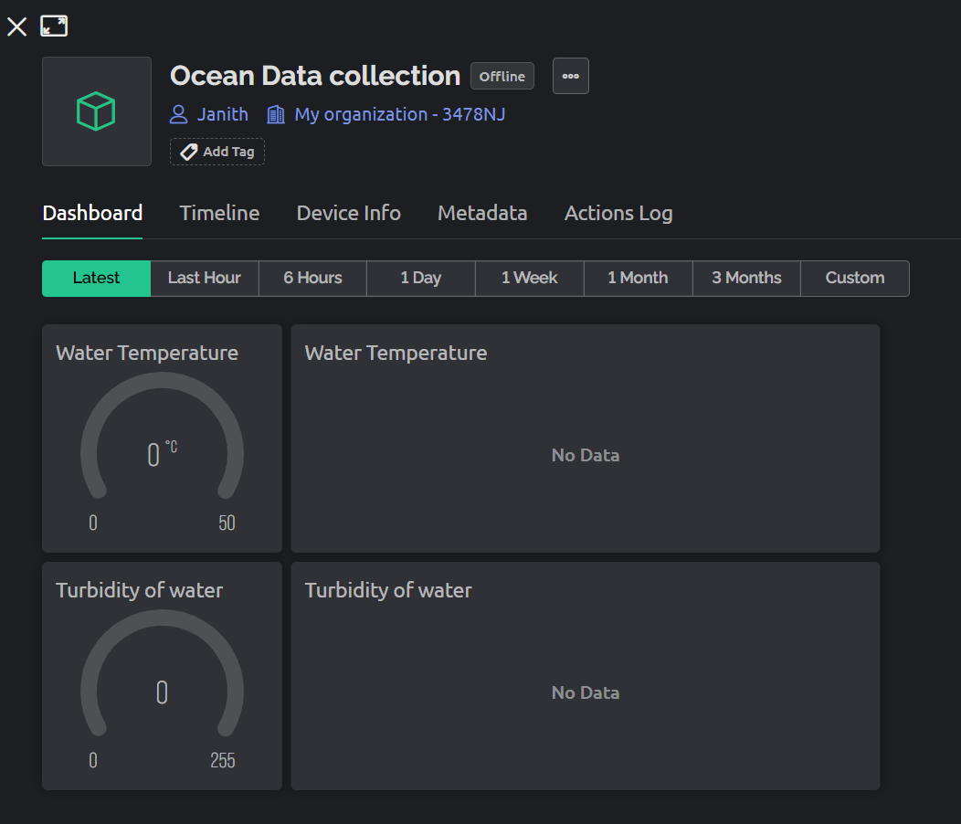

Figure : Web app Interface

Blynk connected to the ESP32 with Blynk Token,

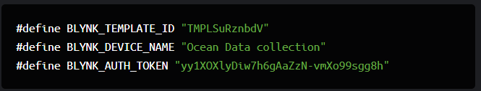

Figure :Firmware Configuration

### Encloser Designing and Manufacturing

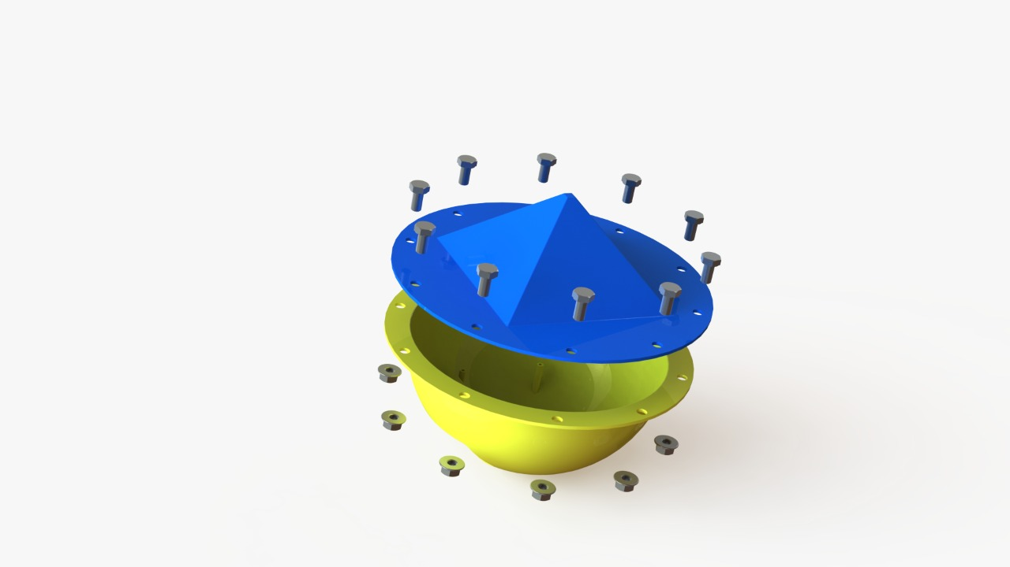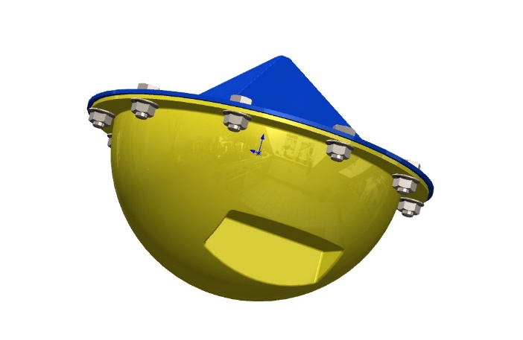

Figure : 3D model of Encloser

Sensor network encloser designed using Solidworks. When designing the encloser considered about the floating, Balancing, water tinting, Circuit placing and sensor connectors.

# Result and Discussion

There are lots of research conduct around the Sri Lankan Sea and they used to get data in manually. So, this data acquisition system will help to the get data with more accuracy. Only considered about temperature and turbidity. But Salinity, pH value and water pressure is also major measurements that are taking from lagoons.

## Final Product

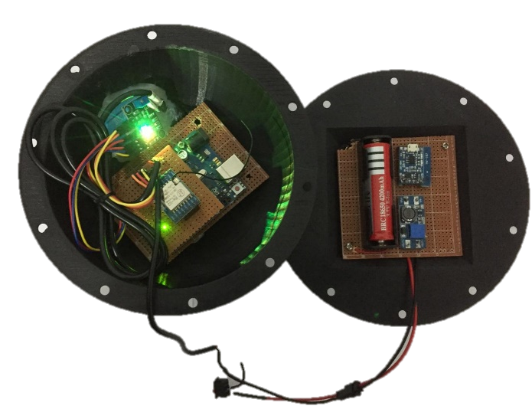

Figure : Inside view of Sensor Network

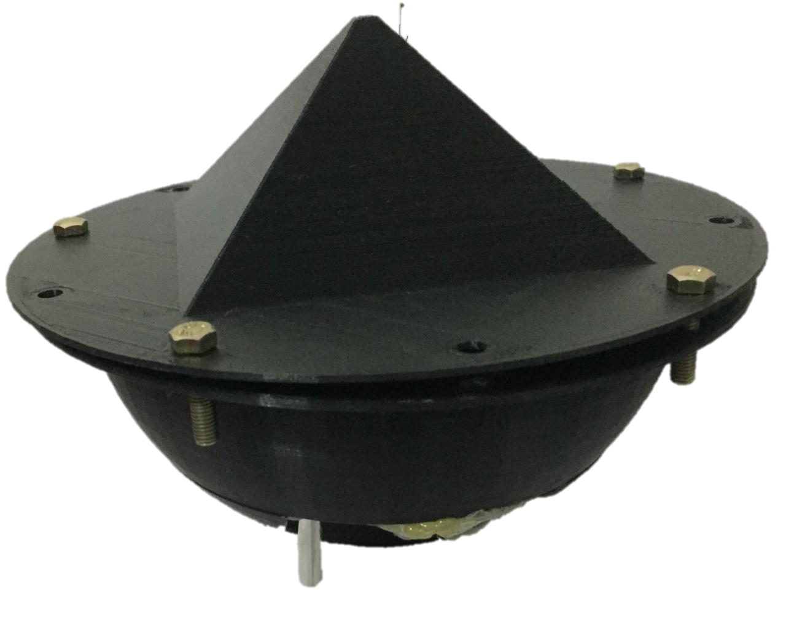

Figure :Outside view of Sensor Network

## Data visualization of web app

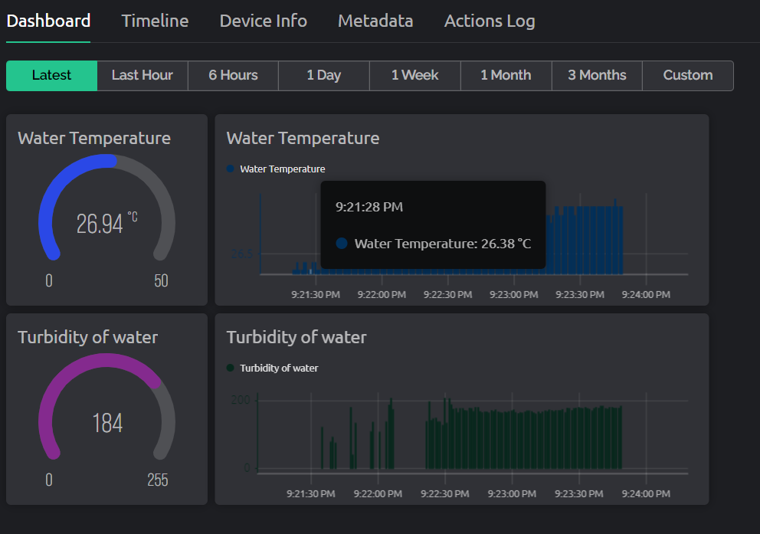

Figure : Data Visualization of Blynk web app

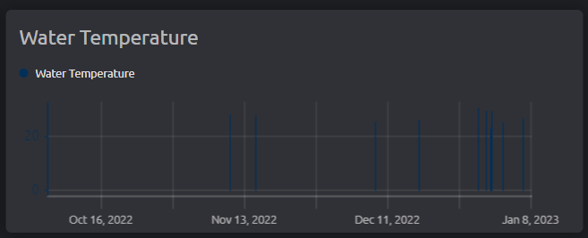

Figure : 3 month data of water temperature

# Conclusion

Main goal of this work was helps to increase marine data acquisition technology in Sri Lanka. Water temperature, Salinity, Turbidity, pH parameters have been widely used in several marine studies. This device powered with Arduino Uno and ESP32 modules. Basically, there is two parts such as, Transmitter (Sensor Network) and Receiver. Advantages of this unit it is easy to configure and use, High data accuracy and can use remotely.

# References

[1] S. MUTHUCUMARAN, S. PATHMARAJAH, and M. I. M. MOWJOOD, “Vertical Variation of Salinity, Electrical Conductivity, Temperature and pH of Batticaloa Lagoon,” *Int. J. Appl. Phys. Sci.*, vol. 1, no. 2, 2015, doi: 10.20469/ijaps.50003-2.

[2] M. Rivas Casado, M. Palma, and P. Leinster, “Autonomous Systems for the Environmental Characterization of Lagoons,” *Lagoon Environ. Around World - A Sci. Perspect.*, pp. 1–16, 2020, doi: 10.5772/intechopen.90405.

[3] S. Kröger *et al.*, “Sensors for observing ecosystem status,” *Ocean Sci.*, vol. 5, no. 4, pp. 523–535, 2009, doi: 10.5194/os-5-523-2009.

[4] T. P. Bean *et al.*, “a review of the tools used for marine monitoring in the UK: Combining historic and contemporary methods with modeling and socioeconomics to fulfill legislative needs and scientific ambitions,” *Front. Mar. Sci.*, vol. 4, no. AUG, 2017, doi: 10.3389/fmars.2017.00263.

[5] M. O. E. A. R. ENERGY, “Energy demand management by introducing T5 fluorescent lamps and Solar tubes to replace four foot T8 fluorescent lamps operated with magnetic ballasts .,” p. 84.

[6] H. Bashithage, U. Gangani, and M. Wimalasiri, “OFF THE SOUTH COAST AND PUTTALAM LAGOON OF,” 2020.

[7] P. R. Manual, “Arduino ® UNO R3 Target areas : Arduino ® UNO R3 Features,” pp. 1–13, 2022.

[8] , “Ds18B20,” vol. 92, no. 1 (35), pp. 1–20, 2015.

[9] DSROBOT, “Turbidity_sensor_SKU__SEN0189.” https://wiki.dfrobot.com/Turbidity_sensor_SKU__SEN0189 (accessed Dec. 29, 2022).

[10] U. Noreen, E. Ahcenebounceuruniv-brestfr, and L. Clavier, “International Conference on Advanced Technologies for Signal and Image Processing, ATSIP 2022,” *Int. Conf. Adv. Technol. Signal Image Process. ATSIP 2022*, 2022.